

User Manual

DVTk RIS Emulator 5.1.1

*A DVTk based tool*

March 17, 2020

**Table of Contents**

1 Introduction 3

1.1 General 3

1.2 System Requirements 3

1.2.1 Operating system 3

1.2.2 Software requirements 3

2 Software installation 4

2.1 Installation of DVTk RIS Emulator software 4

3 Functional description of the SCP emulator 4

3.1 Menu bar 5

3.2 Tool Strip 6

3.3 Information Screen Selection 7

3.3.1 Worklist 7

3.3.2 MPPS 8

3.3.3 Edit DCM Files 9

3.3.4 Logging 10

3.3.5 Validation results 11

3.3.6 Store Files functionality 11

4 Supported DICOM SOP Classes 14

5 Supported transfer syntaxes 15

# ****Introduction****

## General

The DVTk RIS Emulator application handles Modality Worklist C –FIND and Modality Performed Procedure Step N-Create & N-Set requests from remote applications. The responses are emulated using the DICOM files indicated by the user. A brief description of the capabilities of the Emulator is given below.

* Configurable Transfer Syntax Selection
* Possibility to generate random digits in attribute values (e.g. for creating unique ID's) every time the RIS emulator is started.
* C-FIND Responses can be sent in one of the following modes.
* Using the MWL Information Model
* Using Randomized DICOM Objects

## System Requirements

### Operating system

The following operating systems are supported:

* Windows XP Professional
* Windows Vista
* Windows 7
* Windows 8
* Windows 10

### Software requirements

The following packages are required for the installation of the software packages:

* Microsoft .NET framework 4.0
* DVTk Definition Files

The Microsoft .NET framework software package is included in the installer of the **DVTk RIS SCP emulator** tool.

See: http://www.dvtk.org for new versions and features.

# Software installation

All the steps of the installation process are controlled by the DVTk RIS SCP emulatorinstaller package. During the installation process, the installer will check if the Microsoft .NET Framework R4.0 is already installed on the system. The user will have to download the .NET framework and install it if it is not present. If present, this step of the installation process will be skipped.

## Installation of DVTk RIS Emulator software

1. Download the installer to a temp directory on the PC.
2. Start the installation procedure by double clicking with the left mouse button on the .msi file.
3. Follow the instructions of the installer.

In windows “All programs” there is an entry created “DVTK”. When selecting DVTK, a submenu with all installed DVTK applications will be opened. From this submenu the RIS Emulator tool can be selected and started.

# Functional description of the SCP emulator

In the screen capture below, the User Interface of the Query Retrieve SCP Emulator tool is shown:

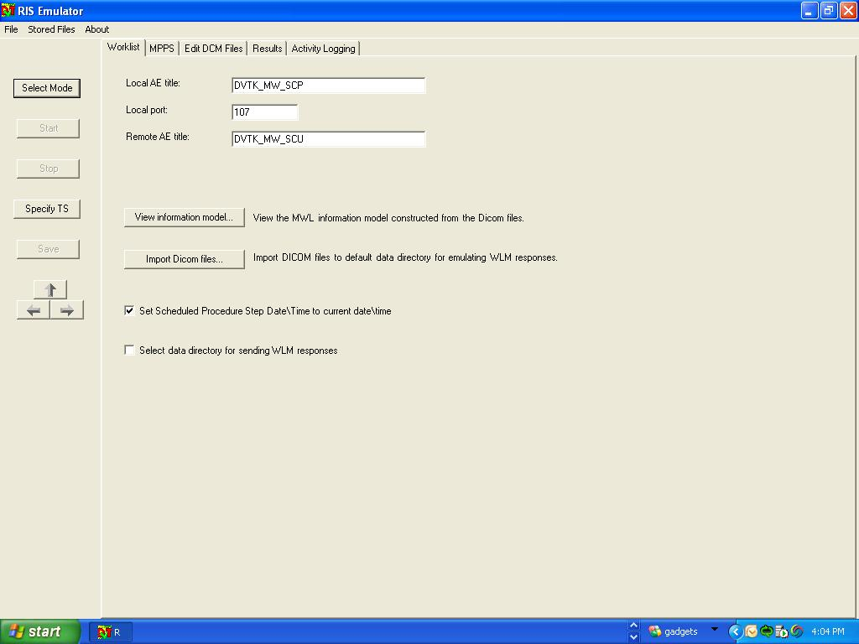

The RIS Emulator start up window contains the following sections:

## Menu bar

From the Menu bar the following file options can be selected to control the RIS Emulator:

**File:**

* **Config File**
  + Load
  + Save As
* **Exit**

**Stored Files:**

* **Explore Validation Results…**
* **Options…**

**About:**

* **About Emulator**

## Tool Strip

The tool strip(present on the left hand side) contains the following short keys to control the QR SCP emulator process:

**Select Mode**

Clicking this button will display a box containing the 2 modes in which the C-FIND responses can be sent-Using the MWL Information Model and Using Randomized DICOM Objects. The user can select the preferred mode

**Start**

Clicking this button will make the SCP emulator listen for incoming association requests .

**Stop**

Clicking this button will stop the emulator.

**Specify TS**

Clicking this button will display a box containing various transfer syntaxes. The user can select the Transfer Syntax which the emulator must support.

**Save**

Clicking this button will save the configured parameters to the emulator’s session file(WLM_SCP.ses & MPPS_SCP.ses)

## Information Screen Selection

The following Tabs can be selected for display

* Worklist
* MPPS
* Edit DCM Files
* Activity Logging
* Validation results

### Worklist

In the Worklist tab, the parameters for the communication with the SCP as well as the behavior of the SCP emulator can be configured. The configuration parameters are as follows:

* **Local AE title**

AE title used by the SCP emulator

* **Local Port**

Listen port of the RIS SCP emulator for incoming associations.

* **Remote AE title**

AE title used by the SCU

* **View Information Model**

Clicking this button will display the information model(constructed with the DICOM Files used for sending the emulator responses).

* **Select Data Directory for sending WLM Responses**

The user can select the data directory containing the DICOM Files which are used to emulate the responses of the emulator to Worklist requests. The default directory is:

C:\Program Files\DVTk\RIS Emulator\Data\Worklist\

* **Import DICOM Files**

The user can use this option to import additional DICOM files to the Data Directory used for sending QR responses.

### MPPS

In the Worklist tab, the parameters for the communication with the MPPS SCP can be configured. The configuration parameters are as follows:

* **Local AE title**

AE title used by the SCP emulator

* **Local Port**

Listen port of the RIS SCP emulator for incoming MPPS messages.

* **Remote AE title**

AE title used by the SCU

### Edit DCM Files

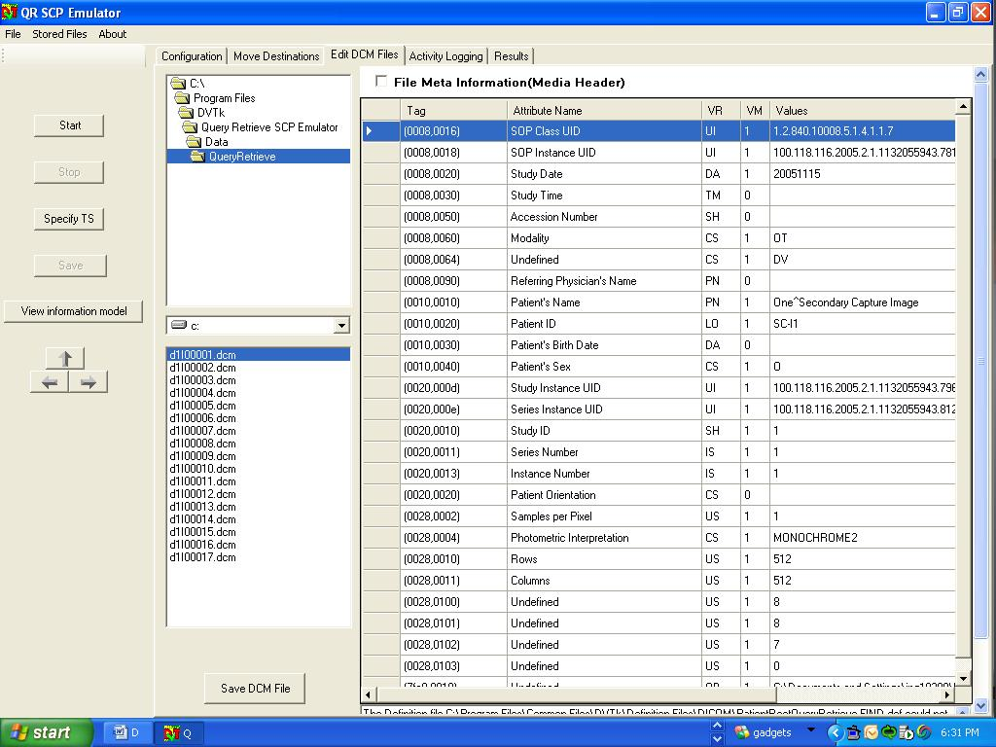

The DICOM Files used for emulating the MWL responses can be edited using the Editor shown above.

To let the RIS emulator generate random digits in attribute values, insert the character '@' in attribute values (use the "Edit Dicom Files..." button for this).When the Query/Retrieve emulator is started, each '@' will be replaced by a random digit (0-9). Multiple '@' characters may be inserted next to each other in attribute values to create a large random number. When the RIS emulator is stopped and started again, these random digits will be newly generated. It is only possible to insert the '@' character in attributes with the following VR's:

* AE (Application Entity)
* AS (Age String)
* CS (Code String)
* DA (Date)
* DS (Decimal String)
* DT (Date Time)
* IS (Integer String)
* LO (Long String)
* PN (Person Name)
* SH (Short String)
* TM (Time)
* UI (Unique Identifier)

### Logging

After the SCP emulator has been started, the log window becomes automatically active and shows the progress of the emulator operation.

An example of log information is given in the screen capture below:

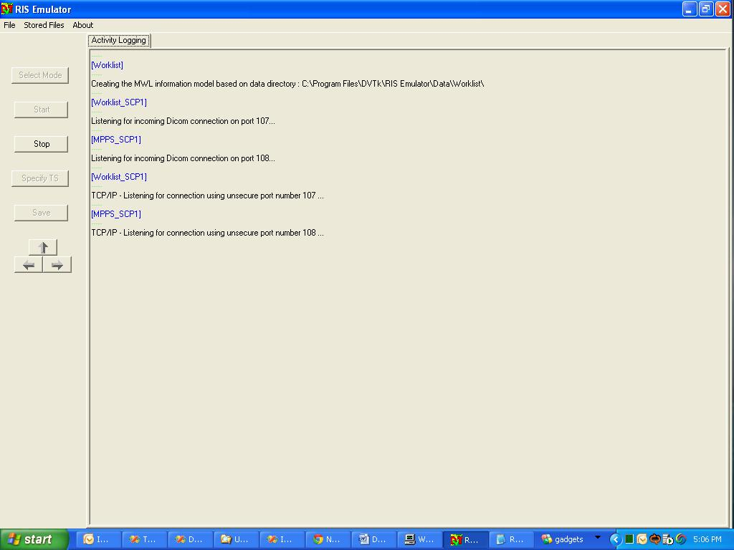

### Validation results

The validation results of all received DICOM messages and data objects are displayed.

**Validation results example:**

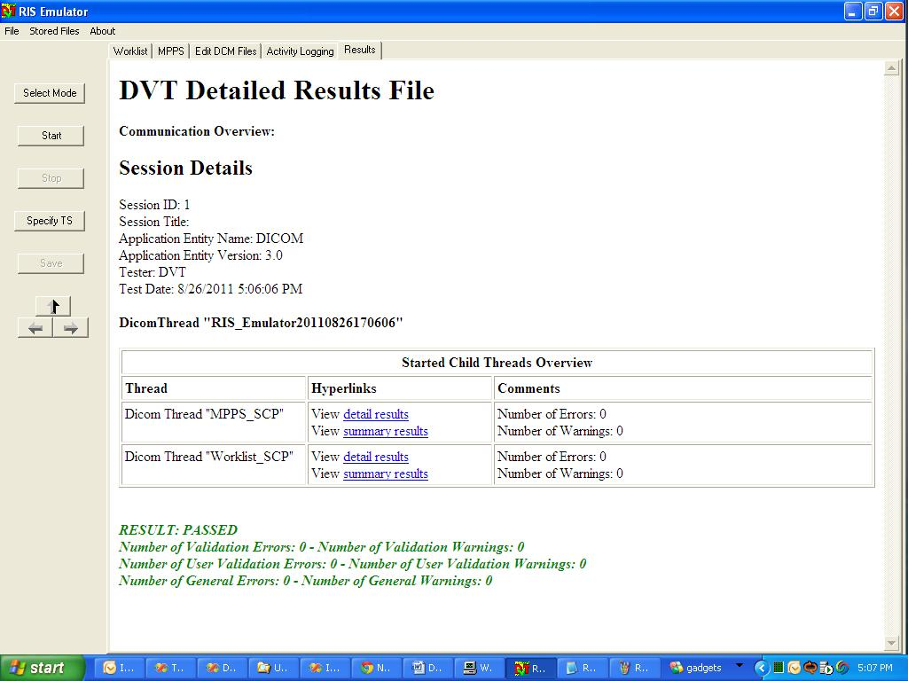

### Store Files functionality

User can configure/explore the result and data directory for emulator by using this option. The screen shot is as shown below:

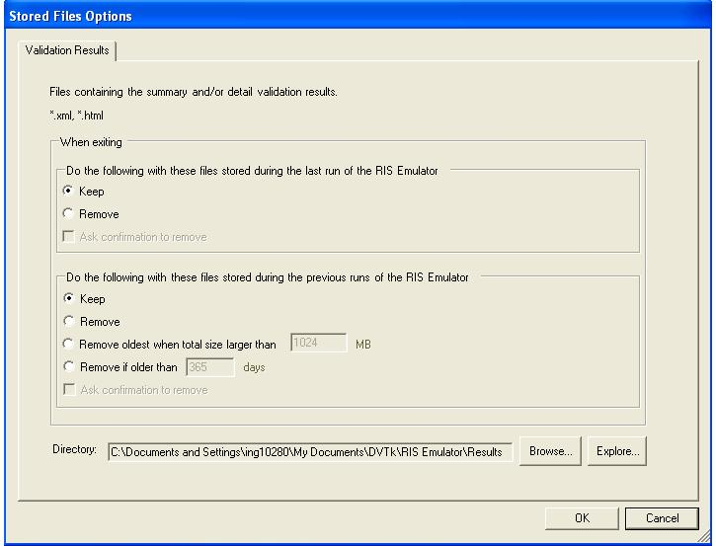

**Validation Results Tab**

With the “Browse” button, a directory can be selected for the storage of the result files.

The default result directory will be:

**On Windows XP -** C:\Documents and Settings\username\My D ocuments\DVTk\RIS Emulator\Results

**On Windows Vista and Windows 7 -**  C:\Users\username\My Documents\DVTk\RIS Emulator\Results

With the “Explore” button, Windows explorer is started and shows the contents of the result directory.

**Cleanup of Result and Received DICOM message files**

Various options are provided for storing old result (xml/html) files and DICOM message (*.dcm) files when application exits or for previous runs as shown in above screen shot.

# Supported DICOM SOP Classes

The DVT RIS emulator supports the SOP classes that are listed in the table below:

|  |  |
| --- | --- |
| 1.2.840.10008.5.1.4.31 | Modality Worklist Information  Model – FIND |
| 1.2.840.10008.3.1.2.3.3 | Modality Performed Procedure Step SOP Class |
| 1.2.840.10008.3.1.2.3.4 | Modality Performed Procedure Step Retrieve SOP Class |
| 1.2.840.10008.3.1.2.3.5 | Modality Performed Procedure Step Notification SOP Class |
| 1.2.840.10008.1.1 | Verification SOP Class |

Table 4-1 Supported SOP classes

# Supported transfer syntaxes

The transfer syntaxes supported by the SCP emulator are listed in the table below.

|  |  |
| --- | --- |
| 1.2.840.10008.1.2 | Implicit VR Little Endian |
| 1.2.840.10008.1.2.1 | Explicit VR Little Endian |
| 1.2.840.10008.1.2.2 | Explicit VR Big Endian |

Table 5-1: Supported transfer syntaxes